OBJECT ORIENTED Programming Project Report

Project Tittle:

# Point Of Sale System

DEPARTMENT OF COMPUTER SCIENCE

## BAHRIA UNIVERSITY, KARACHI, PAKISTAN

Course code:CSL210

Lab Instructor:

Miss Salas Akbar

Group Members:

Furqan Ahmed (02-134212-106)

BSCS-2B

# TABLE OF CONTENT

|  |  |
| --- | --- |
| *1* | *INTRODUCTION* |
| *2* | *Data base explaination* |
| *3* | *Flow chart and UML Diagram of the system* |
| *4* | *Screenshots of the forms with explaination* |
| *5* | *Code Snippets* |
| *6* | *CONCLUSION* |

# Introduction

Point of sale systems are proving to be a vital part of businesses today. A point of sale system (POS) has many capabilities beyond what you will get from your typical cash register. These capabilities prove very beneficial to businesses and can lead to increased profits and efficiency. a POS system can provide employees and customers a more efficient way of cashing out. These systems store orders once they are placed.

When a customer comes to your checkout counter to make their payment an employee simply pulls up their check. There is no need to enter each item from a server’s handwritten ticket. This allows for a quicker checkout for customers and allows your cashier to serve more customers in a less amount of time thus being more efficient.

Features of Library Management System Project

The purpose of this project is to reduce the effort of manager and keep the flow of work in an efficient way. And to reduce the manpower and convenient for the customers to checkout their desired goods in an efficient and secure way. During busy days the (POS) systems would prove to be very efficient as they would reduce a noticeable amount of time and effort done by the cashier. The program would automatically generate the bill according to the goods purchases.

It is convenient for both user and workers because it will require less human interaction, and this will create less confusion. And to maintain the user record so that user will know the details and the history of the items purchased.

A few more advantages:

1. To make it easy to keep track of the inventory the store has. It allows to manage the inventory in real-time and to know the number of products store owns over a given period.
2. To allow the owner to record and group all types of invoices all in one place.  
   i.e., distinguish between invoices for purchases, sales, consignments.

Our application would also offer some additional features for the customers i.e.,

1. The system would store their Name and Contact number for future information of available products and sales offered by the store.
2. If a customer shops for more than Rs.10,000 PKR, they will get flat 10% discount on checkout.

Our program will not only care for customer but the employees as well i.e.,

1. By keeping track of hours each employee worked in a day, week, and month.
2. Calculating their salaries according to the amount hours they have worked.

## Database explanation

We have used a MS-Access database named as SystemInfo, to store the information of the system permanently and securely. We have made 6 tables named as LoginInfo, Employee details, Customer details, Supplier details, Product details and Invoice of purchase.

Dashboard OPTION :

We have made two UI’s one for Admin and one for the Employee.

Admin Dashboard contains everything system has i.e., Customer, Supplier, Product details.

To gain access to admin dashboard we just have to login as an admin. And then we will be able to use all other options of admin.

In order to use Employee Dashboard, the employee first have to login, and then he can have access to its UI.

Employee Dashboard only have access to POS Terminal and Invoice history.

## Flow Chart & UML Diagram

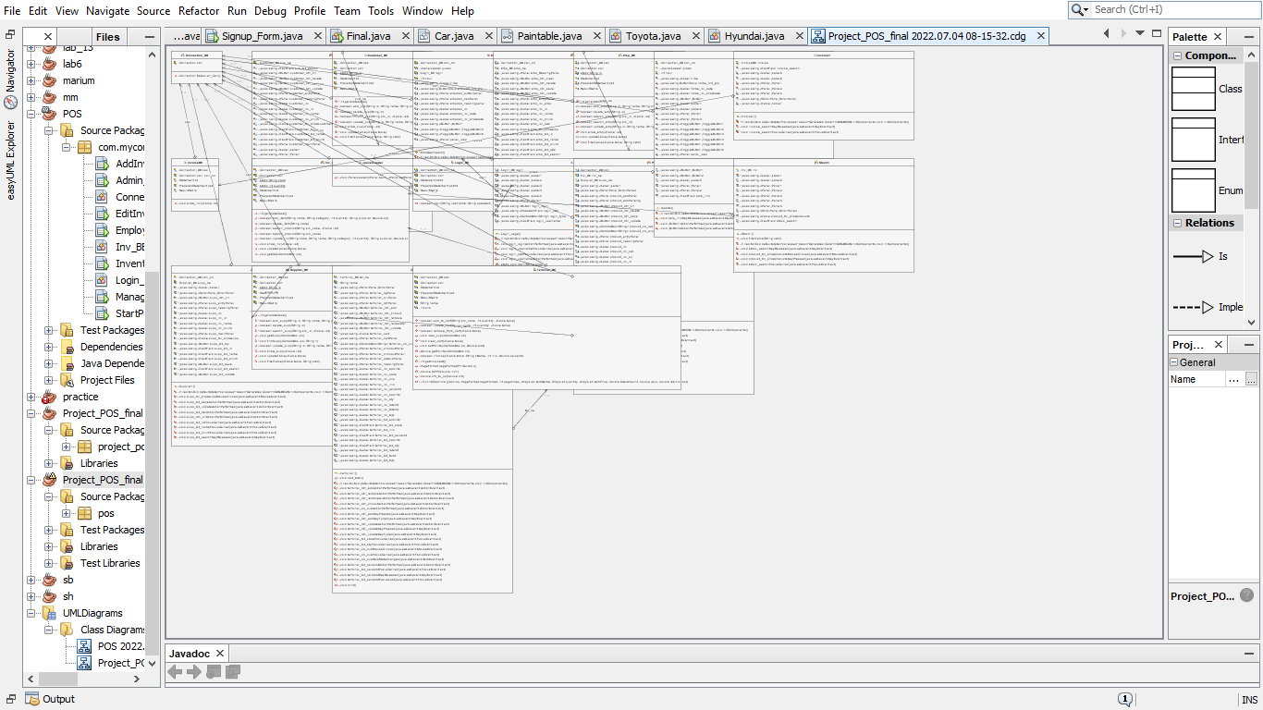

Screenshots of the forms with explaination

Point Of Sale SYSTEM

LOGIN SCREEN:

The login screen has 2 fields and one combo box to choose from Admin or Employee.

Admin Dashboard:

After login screen if you logged in as an admin then you will see this UI.

* Customer Details:

In this area you will be able to add a new customer or modify, delete, search and view all the customers registered.

Supplier Details:

In this area you will be able to add a new supplier or modify, delete, search and view all the suppliers registered.

Employee Details

In this area you will be able to add a new employee or modify, delete, search and view all the employees registered.

Product Details:

In this area you will be able to add a new product or modify, delete, search and view all the products registered.

Invoice:

In this area you will be able to view all the invoices that are done through the terminal, you can also filter through them.

Stock:

In this area you will be able to view all the stock that is present in the inventory , you can also filter through them.

Terminal:

This is the main UI of the program, Here all the important work will take place.

### Code snippets

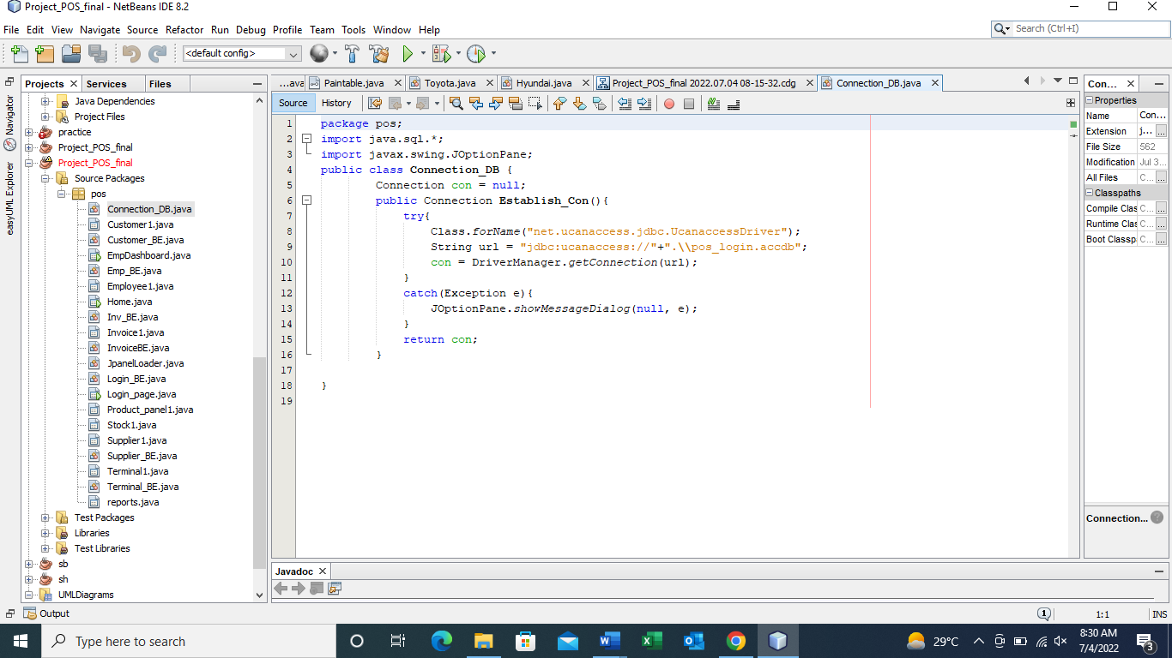

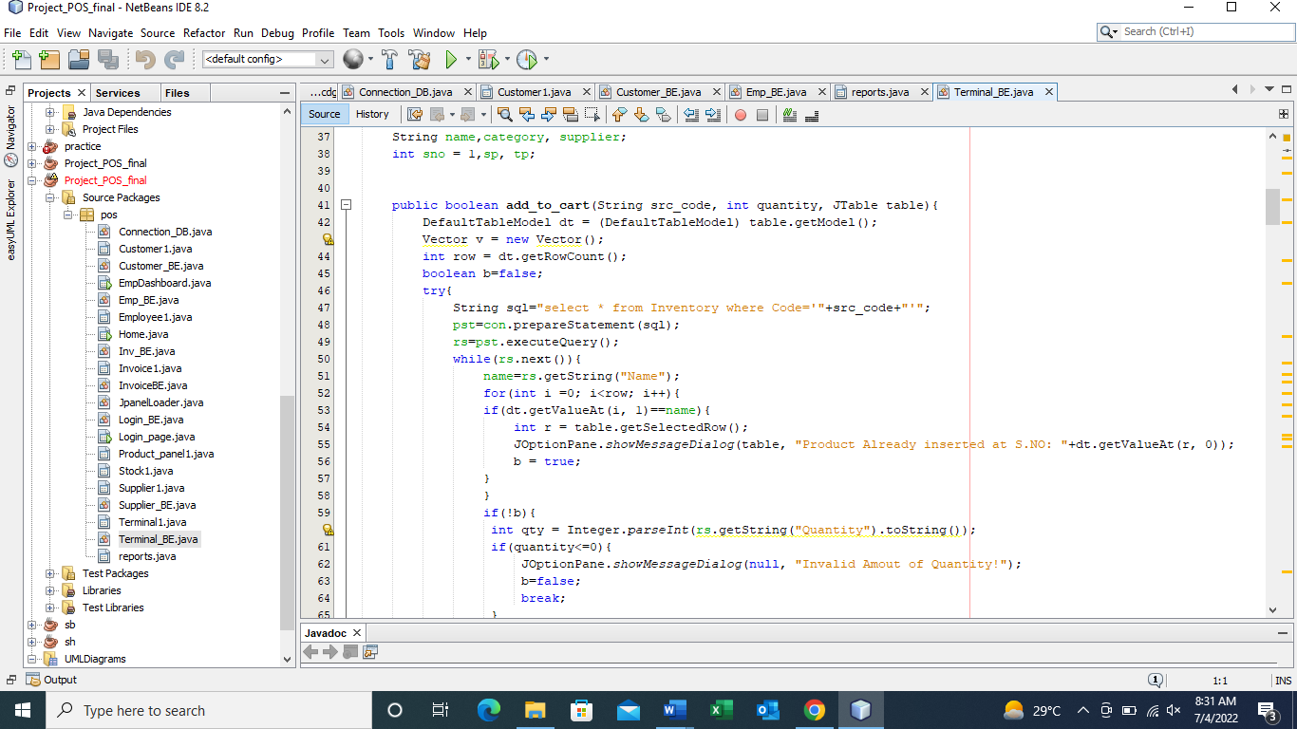

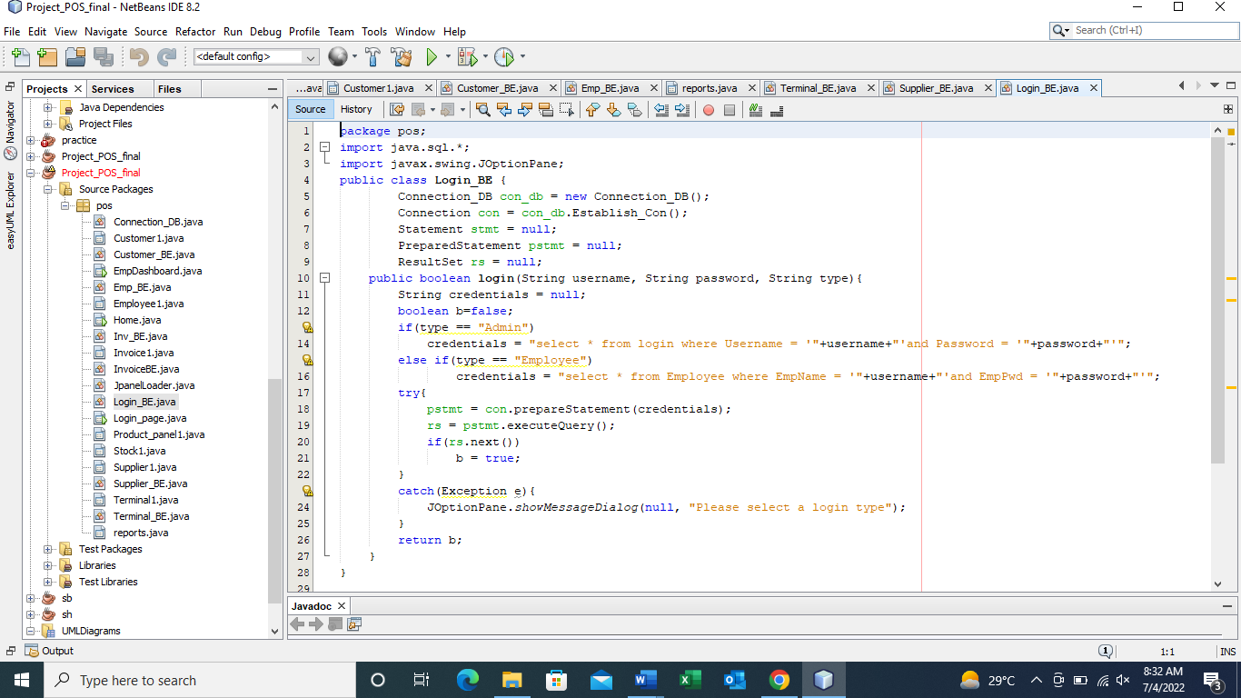

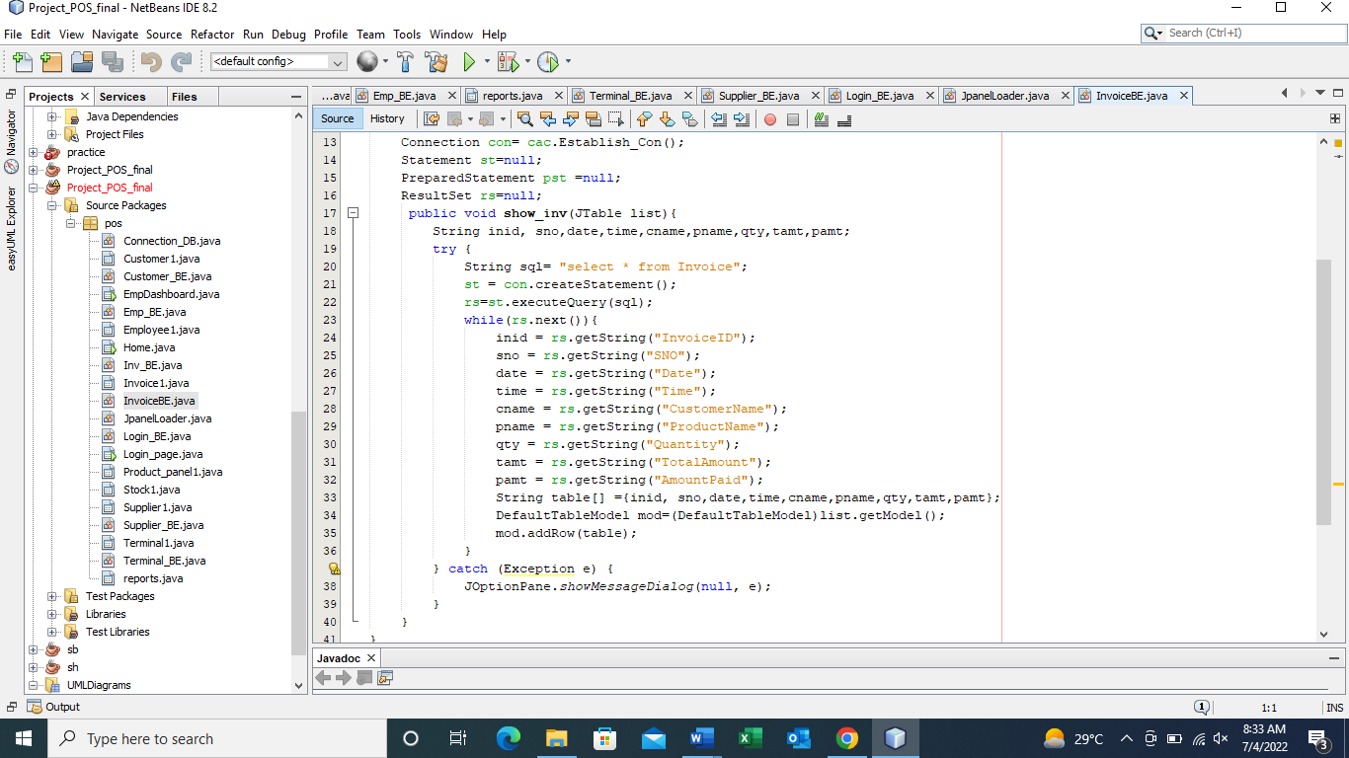

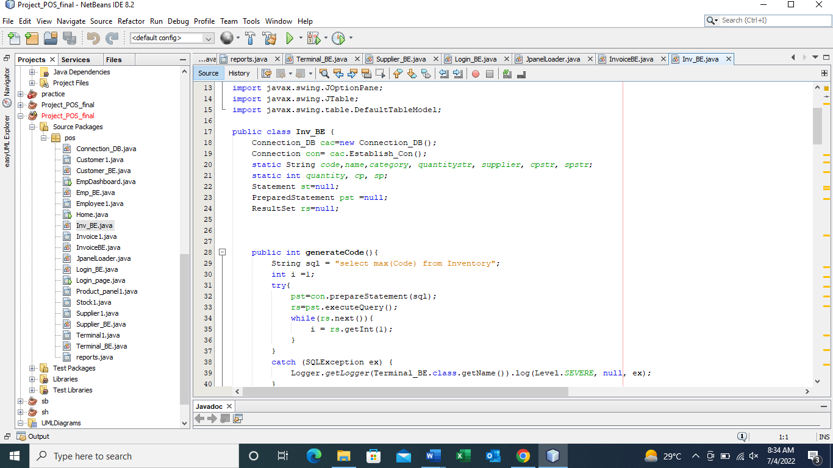

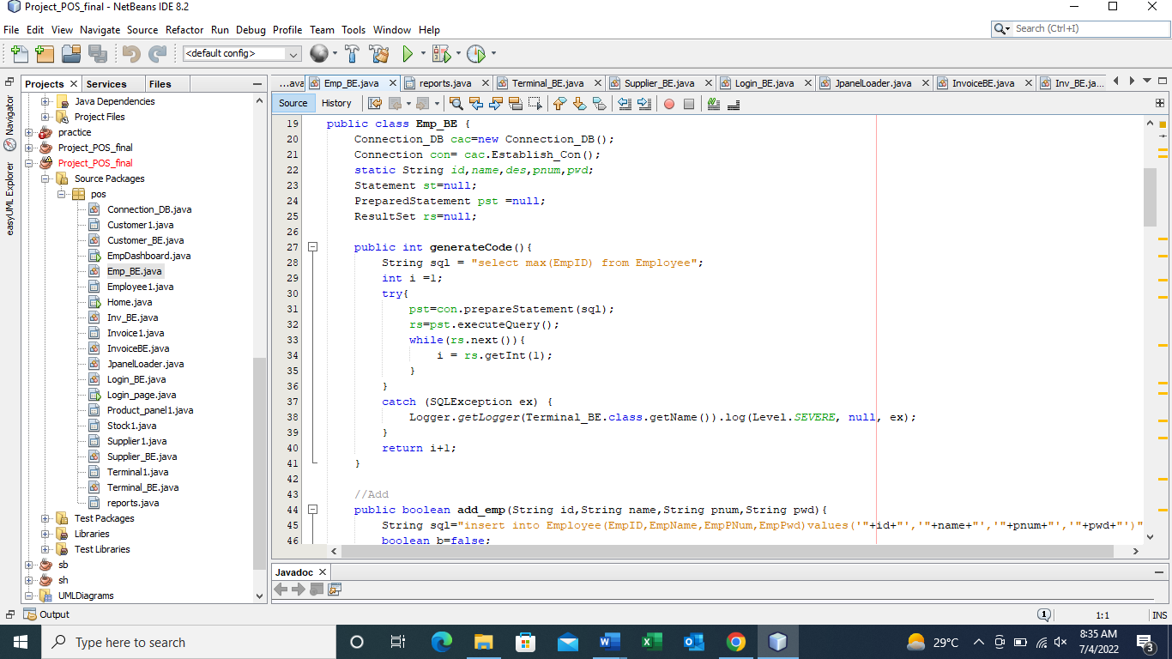

### Conclusion

Point Of Sale System that facilitates the entire range of day-to-day store sales and purchase operations. This powerful system can be deployed on any physical / online store. A solution to increase efficiency, effectively manage increasing workloads associated with engage better with returning as well as new customers.